Localisation Problem

Localisation Errors:

Epsilon = 0.00 Epsilon = 0.02

Epsilon = 0.05 Epsilon = 0.1

Epsilon = 0.2

(The above graphs have been plotted only for 4 observations using spreadsheet software because of time constraints)

1. Here, we find that as error rate(epsilon) increases, the estimate of most likely current state (that we get by using the filtering equation) deviates more from the actual location.
2. We find that inspite of epsilon being as high as 0.2, we get approximately correct locations because of the algorithm’s ability to integrate evidence over time and to take into account the probabilistic constraints imposed on the location sequence by the transition model.

Path accuracy:

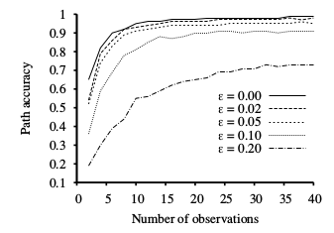

From the above plot, we observe that as the epsilon decreases, the accuracy of the viterbi path keeps approaching towards 1, as should be the case.

